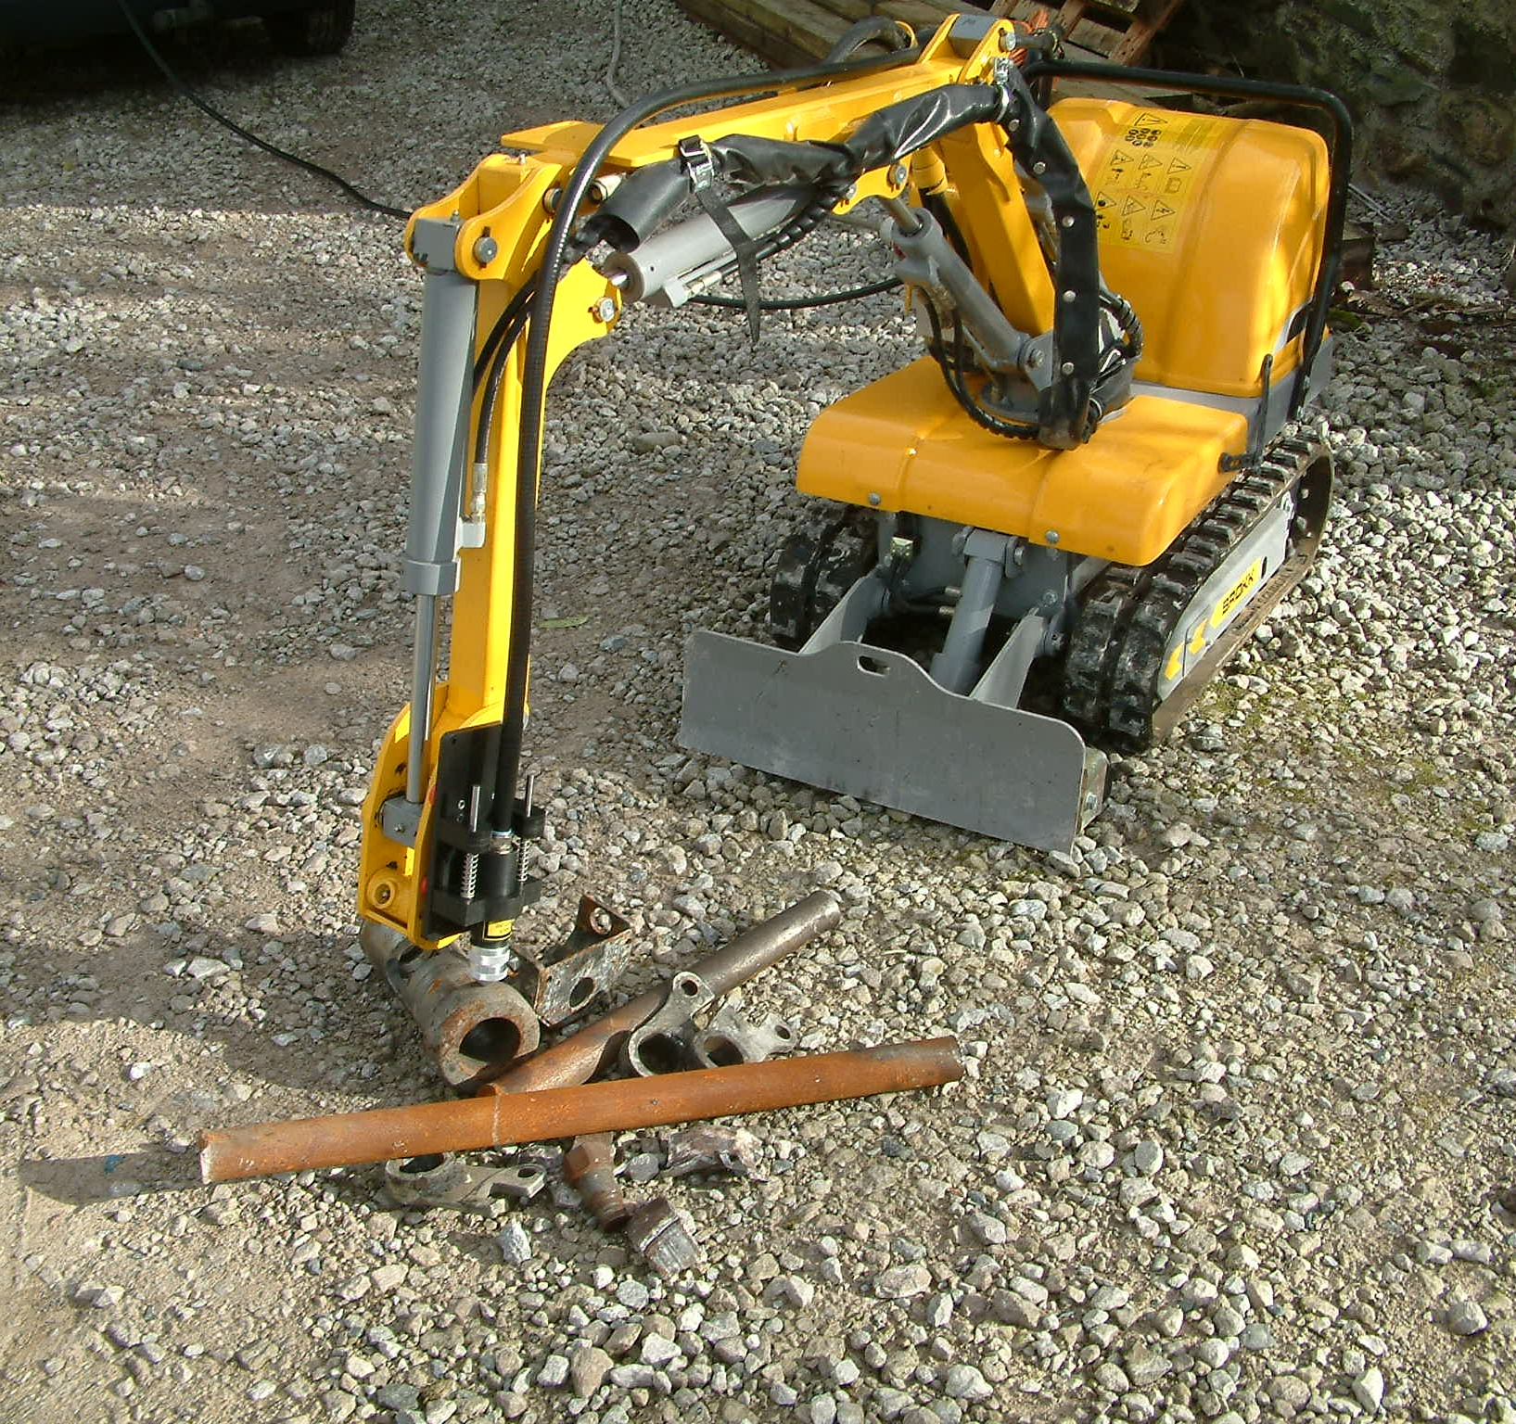
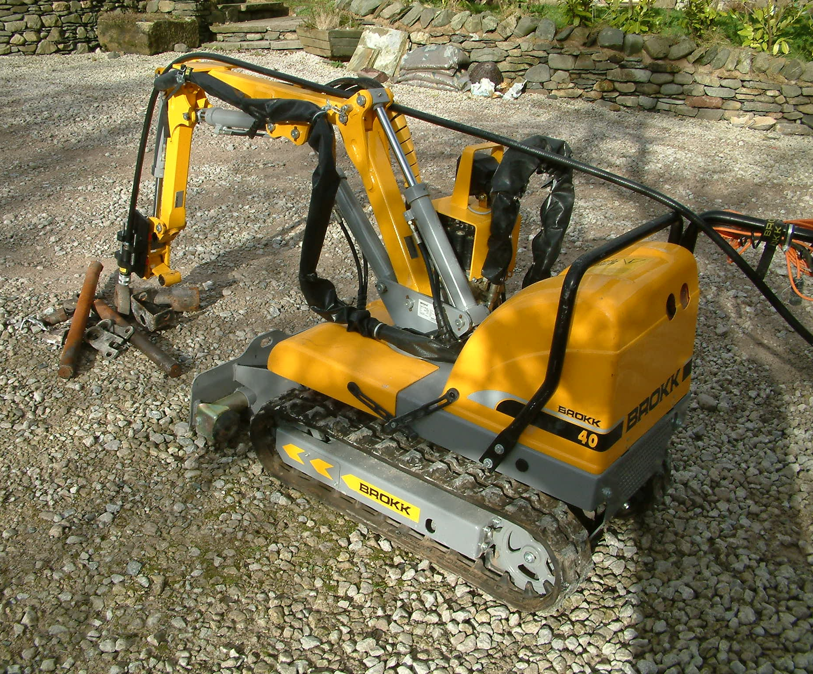
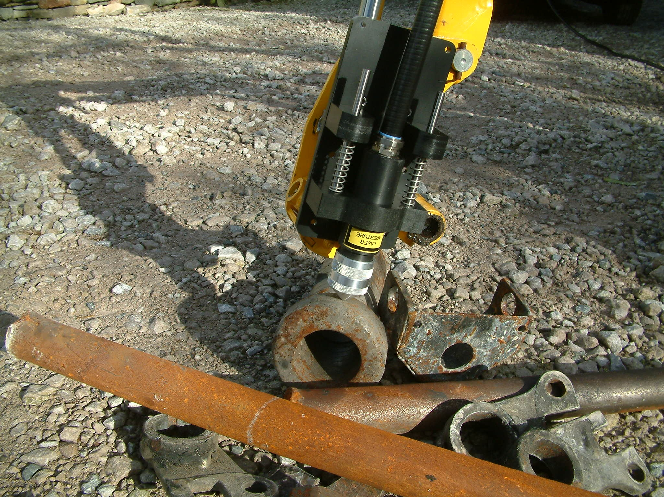

Brokk Inc. and American Measurement Solutions LLC. (AMS) are pleased to announce a cooperative agreement under which the AMS range of laser based measurement and analysis instruments will be integrated with the Brokk range of remotely operated machines to give a unique deployment capability for hazardous areas. This capability is particularly well suited to nuclear, defense and confined access applications. The combination of these two advanced technologies will allow safe, cost-effective and near real-time elemental analysis of materials in the most hazardous of environments. The smallest of these remote systems, as shown above, can be deployed through access holes measuring just 2ft x 3ft. The measurement technique is very well suited for use in high background radiation areas and even underwater.

AMS, a Los Alamos based small business, is the leading commercial provider of materials characterization instruments based on Laser Induced Breakdown Spectroscopy (LIBS) – a technology which provides near instantaneous elemental analysis of materials. Brokk is the leading commercial provider of digital wireless remotely controlled electro-hydraulic machines, well suited to deploy a wide range of standard and custom designed equipment, tools and attachments.

“This unique integration of capabilities provides a safe, efficient and cost-effective measurement option to our customers worldwide. Remote surveys, materials identification / discrimination and analysis can be completed quickly and in complete safety in the most hazardous operating environments” said Tony Marlow of Brokk Inc. Dr Andrew Whitehouse of AMS added “Our proven LIBS technology is unique in its ability to remotely determine the elemental composition of virtually any material in virtually any environment, including high-radiation and other restricted access areas, and offers a cost-effective and safe alternative to physical sampling and off-line laboratory analysis of unknown materials during nuclear clean-up operations. The Brokk machines provide an ideal platform for deploying LIBS in hazardous environments.”

Additional information can be obtained by contacting:

Tony Marlow Dr. Andrew I. Whitehouse
Nuclear Business Development Manager Technical Director
Brokk Inc. American Measurement Solutions LLC.
1 Coral Bell Court Unit 8 Carleton Business Park
Santa Fe, New Mexico 87508 Skipton, North Yorkshire BD23 2DE
(505) 466-3614 (office) United Kingdom
(505) 699-8923 (cell) Tel. +44 (0) 1756 708900,
tmarlow@brokkinc.com mail@appliedphotonics.co.uk

