
In-situ batch identification of Magnox reactor control rods

Background
In August 1993, crack-like indications were discovered in a secondary shut-down control rod at two of the UK's Magnox nuclear power stations. The ensuing investigation concluded that the outer casings of a batch of control rods were manufactured from steel containing abnormally low concentrations of silicon and thus were at risk of increased corrosion and possible premature failure. The location of this batch of control rods within the two reactors was, unfortunately, not known and hence a method of identification was required. The control rods in question were in-service and were therefore highly radioactive. Physical sampling followed by laboratory analysis, besides being a time-consuming and costly process, was ruled out due to the risk of compromising the mechanical integrity of the control rods. The remote and essentially non-destructive analysis capabilities of LIBS were viewed as having the potential to provide a cost-effective solution to this problem and a fast-track development programme was initiated to design and build a fibre-optic probe LIBS instrument capable of identifying the suspect components.

The LIBS solution
It was realised early on in the development programme that measurement of the low levels of silicon by LIBS would be difficult since the characteristic emission lines of silicon are predominantly in the ultraviolet region and so would be strongly absorbed by the optical fibre. This would compromise the performance of the LIBS instrument and hence the necessary level of measurement accuracy for silicon would be unlikely to be achieved. The specification of the control rod casing steel, however, showed that the low-silicon batch could be uniquely identified if the concentration of manganese and copper could be measured with sufficient accuracy. Accordingly, the LIBS instrument was designed and calibrated to measure the manganese and copper content of the steel. The general design of the LIBS instrument developed for this application is illustrated schematically below.
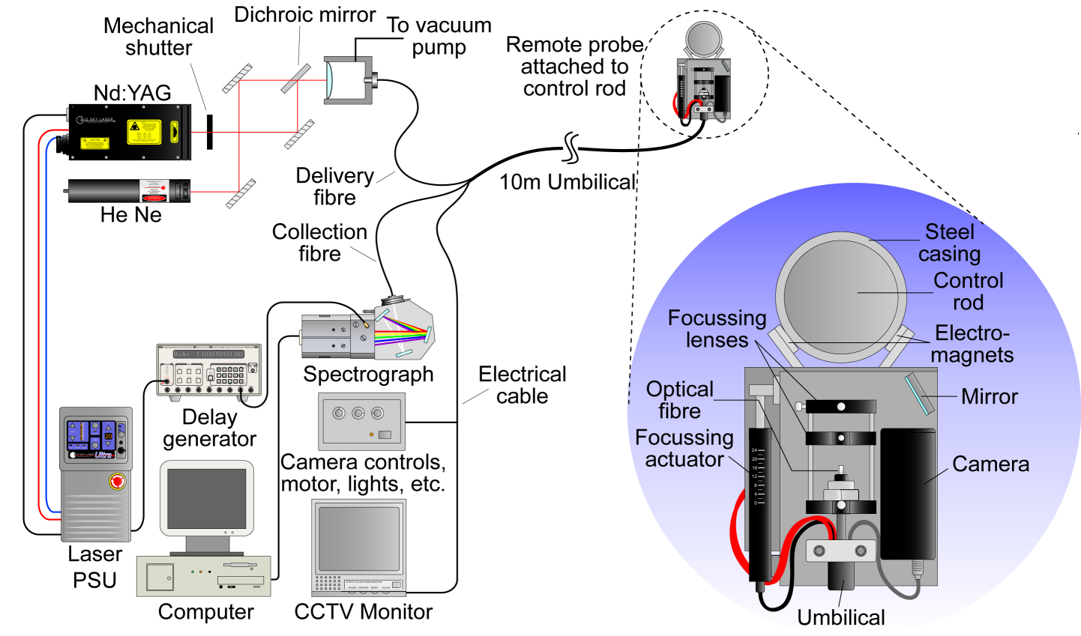
Schematic of the LIBS instrument developed to measure the manganese and copper content of the steel casings of Magnox reactor control rods

The suspect control rods were removed from the reactor and lowered into a hot-cell facility equipped with remote handling equipment. The remote head of the LIBS instrument was designed to pass through a 180-mm diameter access port into the hot-cell and attach to the control rod under examination using a Master-Slave Manipulator (MSM). The remote head was connected to the main control unit of the LIBS instrument via a 10 m length of umbilical that provided mechanical protection for the optical-fibres and electrical cables. A low-power He-Ne laser was included in the design of the instrument, the output of which was launched into the same optical-fibre used to transmit the high-power Nd:YAG laser radiation to the measurement site. A time trace of the reflected He-Ne laser light was recorded to establish when the surface oxide layer had been removed by laser ablation. In this way, the necessary sample preparation was monitored so that LIBS measurements were carried out only when the underlying steel was adequately exposed. In practice, several hundred laser shots were used to prepare the surface of the steel followed by a further one hundred laser shots for the LIBS analysis. The deployment of the LIBS instrument proved to be a great success with each of the suspect control rods being readily identified.

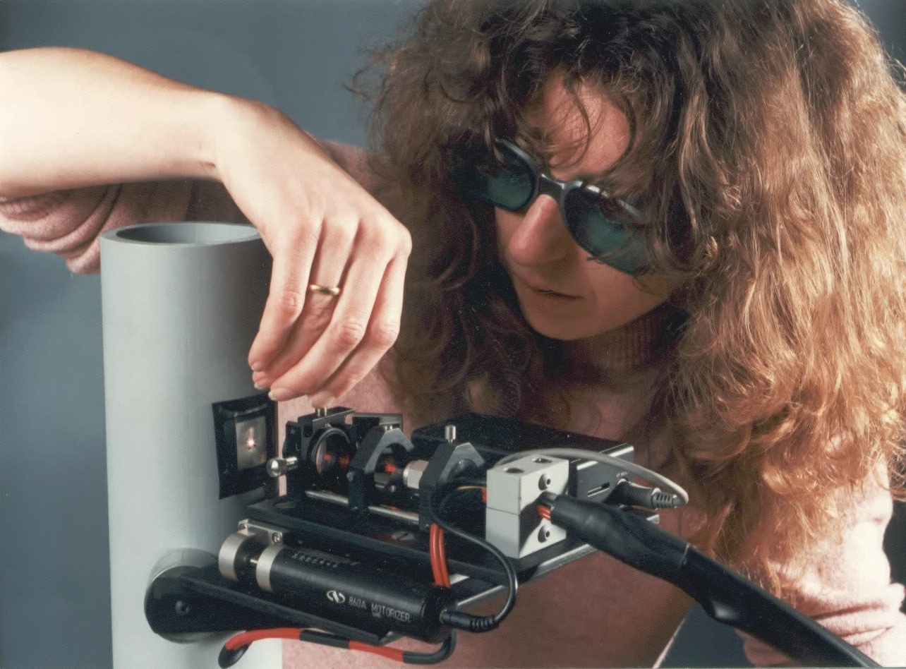
Dr Anna Duckworth making adjustments to the LIBS probe prior to deployment at the Magnox nuclear power station

References
A. Duckworth, Remote metal analysis by laser-induced breakdown spectroscopy, British Nuclear Engineering Society (BNES) Conference Proceedings, Remote Techniques for Hazardous Environments, (1995), pp. 259-263

