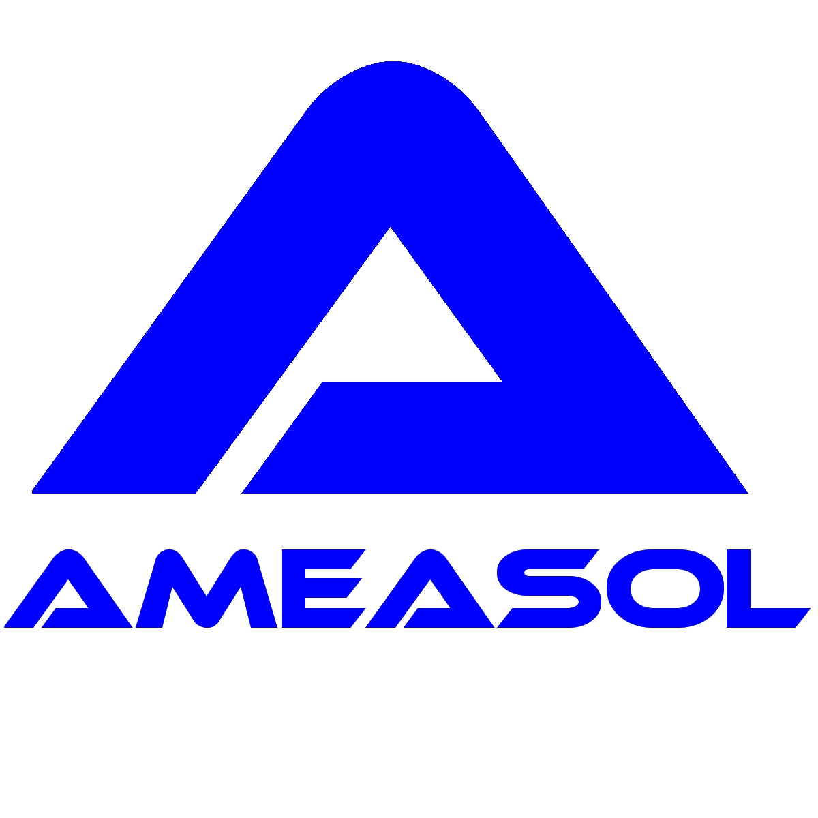
In-situ compositional analysis of economiser tubes within the Sub-Boiler Annulus of an AGR pressure vessel

Background
In early 2001, a fibre-optic LIBS instrument was used to remotely determine the chromium content of mild-steel economiser tubing within the Sub-Boiler Annulus (SBA) of reactor 4 at Hunterston B station. The measurements were required as part of an inspection programme undertaken to identify tubes that had suffered damage through the effects of a process known as erosion-corrosion. Erosion-corrosion is a significant problem in the nuclear industry since it can lead to the thinning of tube walls at rates of up to several mm/yr. Erosion-corrosion is a mechanical process affecting tubes whereby oxide crystals are removed from the surface of the tube wall either by high shear-stress or particles introduced via the flow. Erosion-corrosion has been found to be particularly associated with mild-steel tubing at elevated temperatures of 90-300ºC^{[1]}. The rate of erosion-corrosion depends on various factors including temperature, flow-rate, water chemistry and the composition of the tube material. Tubes manufactured from mild-steel containing less than approximately 0.1% Cr are far more likely to be affected by erosion-corrosion. Accordingly, identification of 'at risk' tubes can be achieved by measuring the chromium content of the tube material.
Access to the SBA was achieved by removing one of the gas-circulators and installing a temporary air-lock and change-room structure within the circulator port. As shown below, the vessel-entrants are required to wear protective clothing and equipment due to the nature of the environment. The fibre-optic umbilical of the LIBS instrument was fed into the SBA via a ventilation duct situated adjacent to the air-lock. Temporary scaffold towers were erected within the SBA to facilitate access to the banks of economiser tubes located directly beneath the steam generators and approximately six metres above the floor level, as shown below.

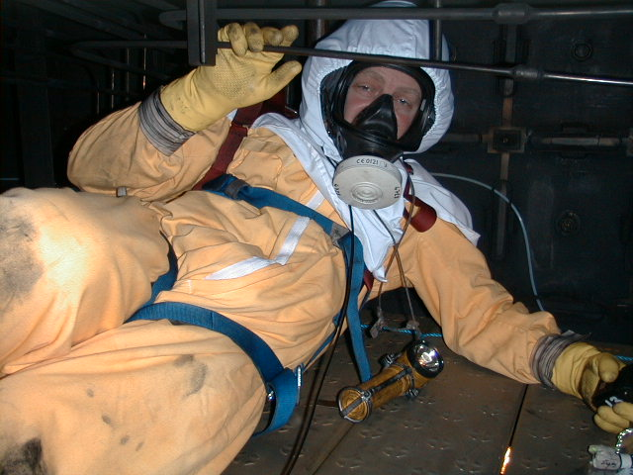 |  | 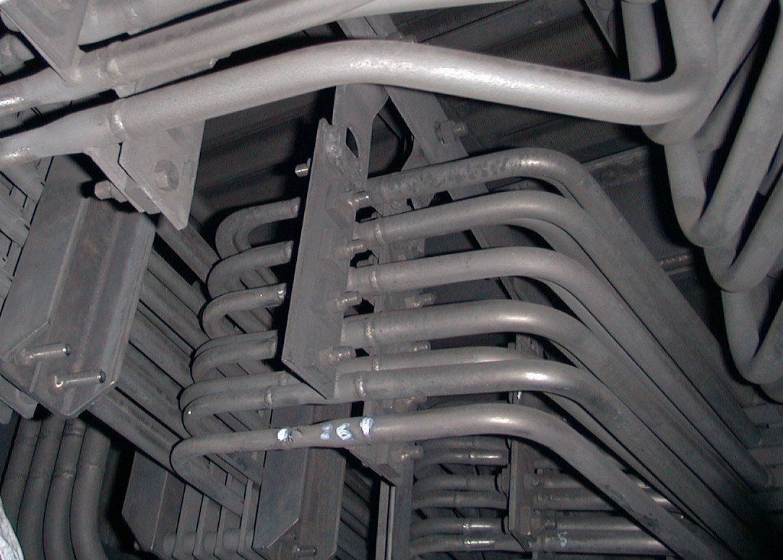
Protective clothing required for working within the Sub-Boiler Annulus |  | View of a bank of economiser tubes situated ~6 metres above the floor of the SBA

The LIBS solution
The LIBS instrument included a 30 metre umbilical and a purpose-designed probe suitable for attaching to the 19.1 mm diameter tubes. Deployment of the instrument required two people; one person to operate the main control unit (the laser operator) and a vessel entrant (the probe operator). The main control unit of the instrument was located outside of the SBA adjacent to the vessel-entry change-room area. A safety electrical switch was fitted to the probe in such a way that the probe operator needed to hold the switch in the on position before the laser operator could activate the Nd:YAG laser.
Calibration of the instrument was achieved using the reference materials given in the table below. All steel samples were certified reference materials (CRM's) with the exception of MGNX 001 which was analyzed by an independent laboratory.
Reference material | Cr (% by mass) | Fe (% by mass)
ECRM 097-1 | 0.0016 | 99.9
MGNX 001 | 0.027 | 99.0
SS 452 | 0.042 | 98.8
SS 434/1 | 0.055 | 97.5
SS 452/1 | 0.067 | 97.6
BS 13B | 0.081 | 98.6
SS 451/1 | 0.104 | 98.3
BS CA 5A | 0.128 | 97.3
SS 435/1 | 0.14 | 98.2
CENIM 301 | 0.165 | 98.2
SS 455/1 | 0.21 | 97.6
SS 433/1 | 0.26 | 98.5
SS 432/1 | 0.31 | 98.0
SS 404/1 | 0.48 | 96.4
Reference materials used to calibrate the LIBS instrument
Calibration measurements were taken using 1600 pre-conditioning, 'burn in' laser pulses (80 seconds) followed by 2 measurements each consisting of 100 laser pulses (10 seconds). These measurements were repeated for 5 different locations on each of the reference materials. The resulting calibration curve is given in the figure below. Small sampling statistics were used to calculate the mean values for each set of measurements. The error bars indicate the 95% confidence limits of a given measurement.
Calibration curve for chromium in mild-steel using a 30 m fibre-optic probe LIBS instrument
The limit-of-detection for chromium was approximately 100 ppm and the measurement precision was typically better than 6%. By performing multiple repeat measurements on a selection of the reference materials over a period of several days, the measurement accuracy was determined to be better than 15%.
The LIBS instrument was deployed successfully at Hunterston B AGR power station in February 2001. Measurements of a number of tubes were carried out, the results of which indicated that the tubes examined were manufactured from steel having a chromium content of higher than 0.1% and hence were unlikely to be affected by erosion-corrosion. These findings were consistent with the results of previous video probe inspections of the internal bore of the tubes which showed that the tubes had not suffered from excessive erosion.
This work was presented at the LIBS 2002 conference^{[2]} held in Orlando, Florida in September 2002.

References
1. B. Poulson, Complexities in predicting erosion-corrosion, Proc. Of Wear – Lausanne, 233-235, (1999), pp. 497-504
2. A I Whitehouse, J Young, C P Evans, Extreme LIBS, Presented at: LIBS 2002, September 25 - 28, 2002, Orlando, Florida, USA

