
Identification of materials within spent fuel cooling ponds using LIBSCAN 400 with a submersible remote probe

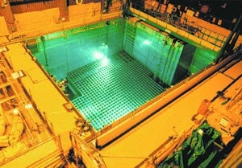
Background
Many of the early-design spent fuel cooling ponds were open to the atmosphere although the more modern ponds utilize a fully enclosed structure to minimize the deposition of airborne contaminants such as salt spray (in coastal sites) or bird droppings. Open ponds are exposed to sunlight and hence suffer greatly from algal growth which can reduce underwater visibility to such a degree that it becomes virtually impossible to visually identify submerged items.

The problem
Example of a modern spent fuel cooling pond
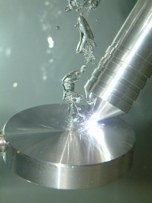
Many of the early cooling ponds are now redundant and so are in various stages of the decommissioning process. Some of these ponds were used as temporary storage sites for a wide range of radioactive waste and so now contain a largely unknown inventory of miscellaneous items of equipment and materials including spent fuel. In addition to having poor visibility due to the presence of algae and other organic material, the water within these older facilities is often heavily contaminated with radionuclides, in dissolved or suspended form, originating from corroded spent fuel assemblies. During the clean-out phase of the decommissioning work, it is necessary to characterize and identify components and materials stored in the pond prior to their removal. One way of achieving this is to obtain physical samples of each component / material so that a laboratory analysis may be carried out. Removal of material from the water can expose personnel to nuclear radiation and may also increase the risk of contamination spread. Furthermore, physical sampling followed by laboratory analysis is a very time-consuming and hence costly process. Characterization of the component / material whilst it is submerged (i.e. in-situ characterization) could offer significant advantages in terms of safety, speed and overall cost reductions.

The LIBS solution
A special version of our fibre-optic probe LIBSCAN 400 instrument which incorporates a submersible remote probe is able to identify the elemental composition of materials submerged in water at any depth up to ~10 metres. The probe operates by ejecting a small amount of gas (air or preferably argon) through the nozzle aperture of the probe. When the probe is in contact with the component under investigation, the water is displaced from the optical path of the laser beam by the gas flow, thus allowing a LIBS analysis of the material to be conducted in a gas medium rather than a liquid medium. Only a “loose” seal between the probe and the component is required – the probe does not have to be normal to the surface of the material and can even tolerate a gap of up to approximately 2 mm. Remote manipulation of the probe is therefore greatly simplified since precise positioning is not required. The small stream of gas escaping from the nozzle of the probe prevents the ingress of water even when the probe is not in contact with the surface of a material.
A 75 mm diameter aluminum disk submerged in water being analyzed by the LIBS instrument
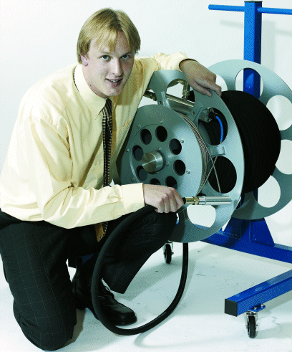
A variety of materials may be quickly and reliably identified using this instrument including uranium, stainless steel, zircalloy, graphite, aluminum, lead and many others. The following raw spectral data obtained using the LIBS instrument illustrate how it is able to discriminate various materials. Analysis is extremely quick and in many cases can be performed in a matter of seconds.

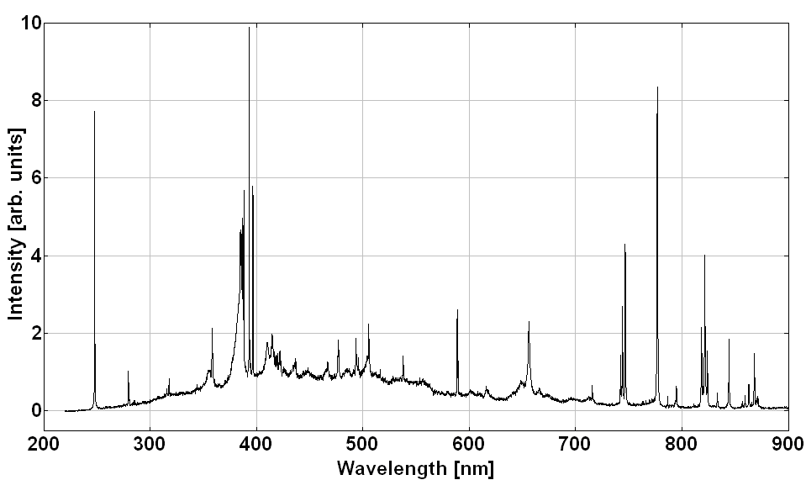
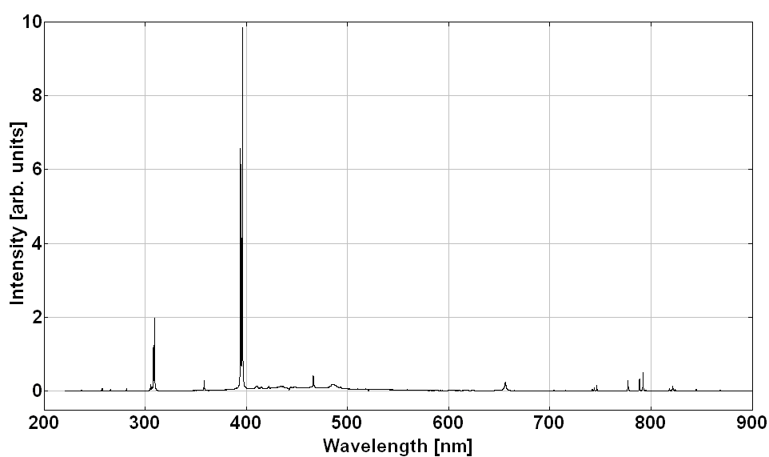
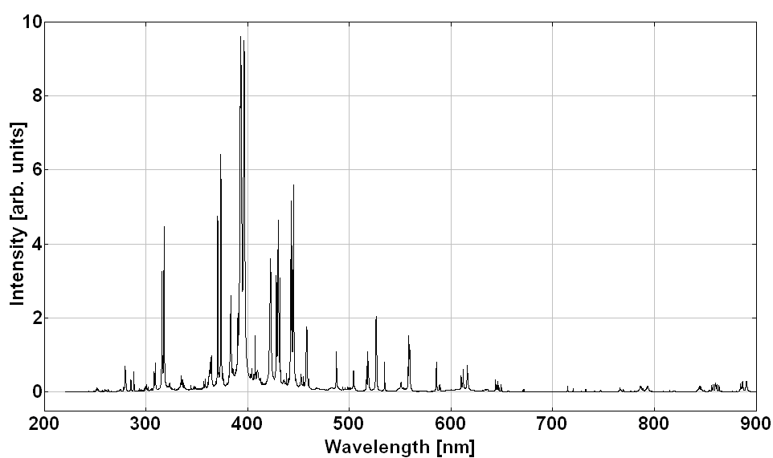
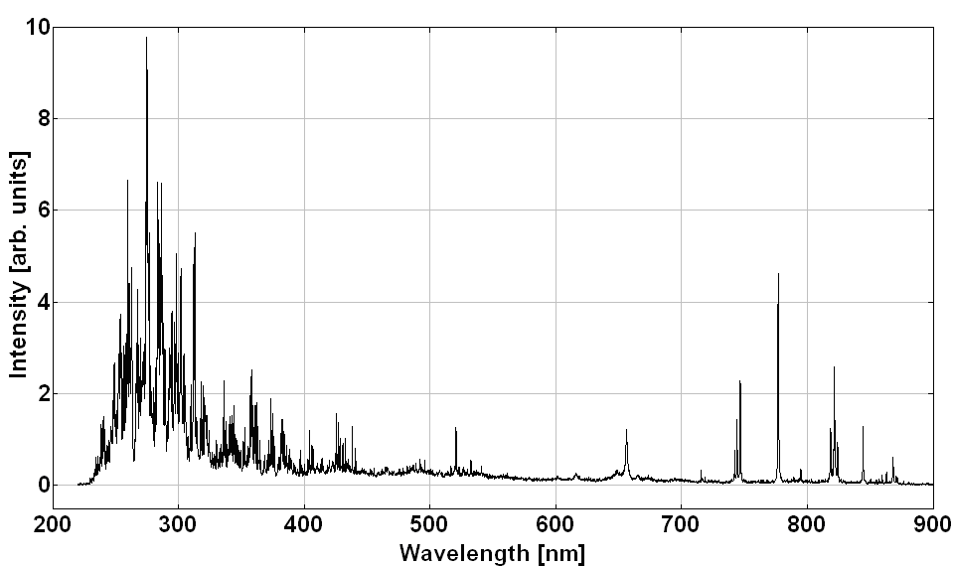
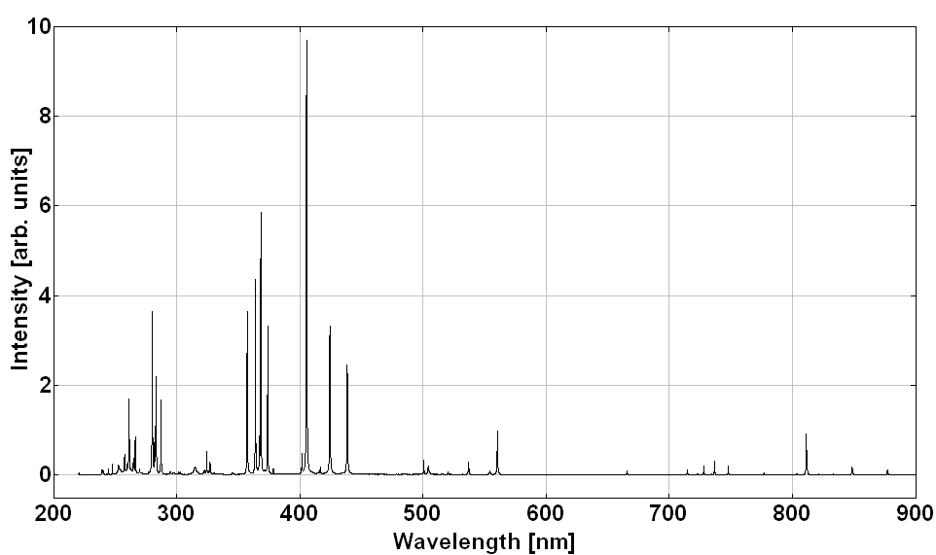
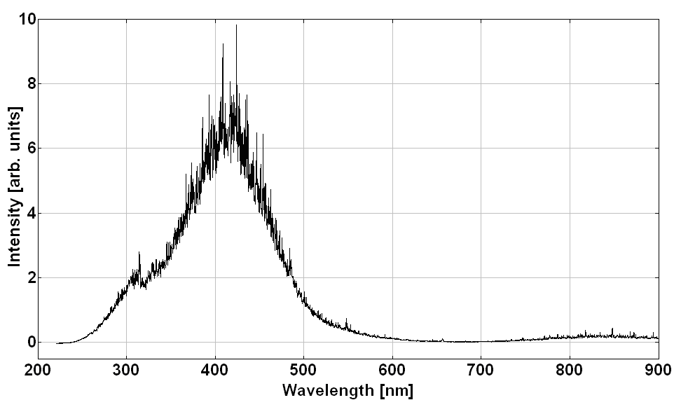
LIBS probe and umbilical
Graphite
Aluminum
Concrete
304L Stainless Steel
Lead
Uranium

