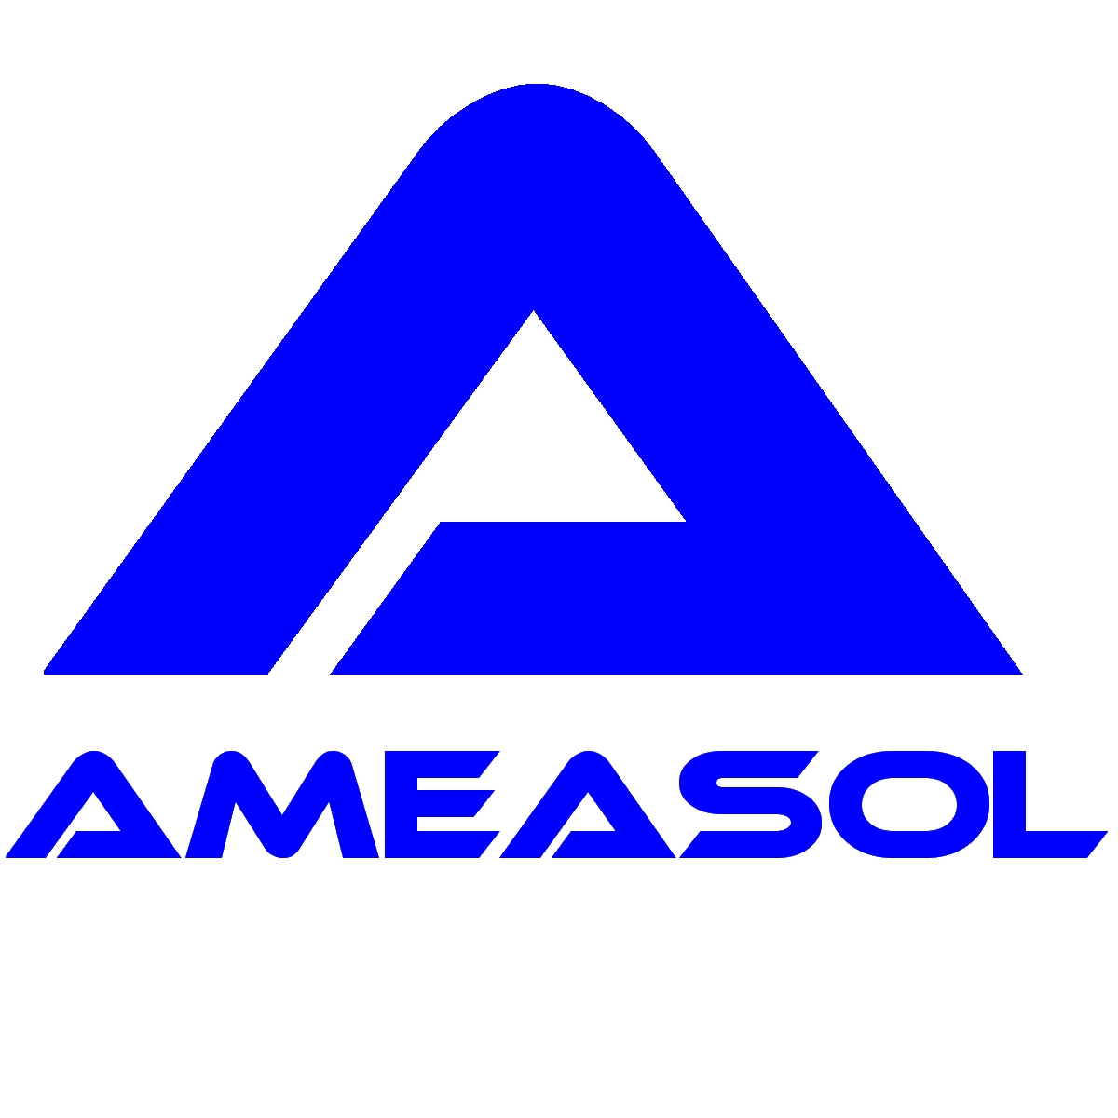
Identification of cooling water tubes and reinforcing bars within Magnox reactor pressure vessels

Background
During a maintenance and repair programme at a Magnox nuclear power station in the UK, there was a requirement to drill a large number of bore-holes into the steel-reinforced concrete pressure vessels of the two reactors. The bore-holes, which were of 20 mm diameter and depth up to 1 metre, were to be used for anchor points for a reinforcing structure being added to the steam penetration tubes. Within the vicinity of the steam tubes, cooling water tubes are embedded in the concrete structure to maintain the temperature of the concrete within certain limits. It was imperative not to damage these cooling water tubes when drilling the boreholes and hence a method was devised to automatically stop the drilling process in the event of contact with a metallic object. Due to the large number of reinforcing bars also present within the concrete structure, a method was required to distinguish between a cooling water tube and a reinforcing bar. Physical access to the component was severely restricted due to the diameter and length of the bore-hole, making the task of identification particularly difficult. As there was line-of-sight access to the steel component, it was proposed to use a LIBS instrument to identify the component through differences in material composition.

The LIBS solution
It was known that the reinforcing bars contain approximately 1.5% manganese while the cooling water tubes contain less than 0.8% manganese. The measurement precision of the LIBS instrument was sufficient to resolve this difference and hence identification of the component could be achieved. A purpose-designed LIBS instrument, illustrated schematically below, was subsequently developed for this application and consisted of a control unit with umbilical connection to a laser module.

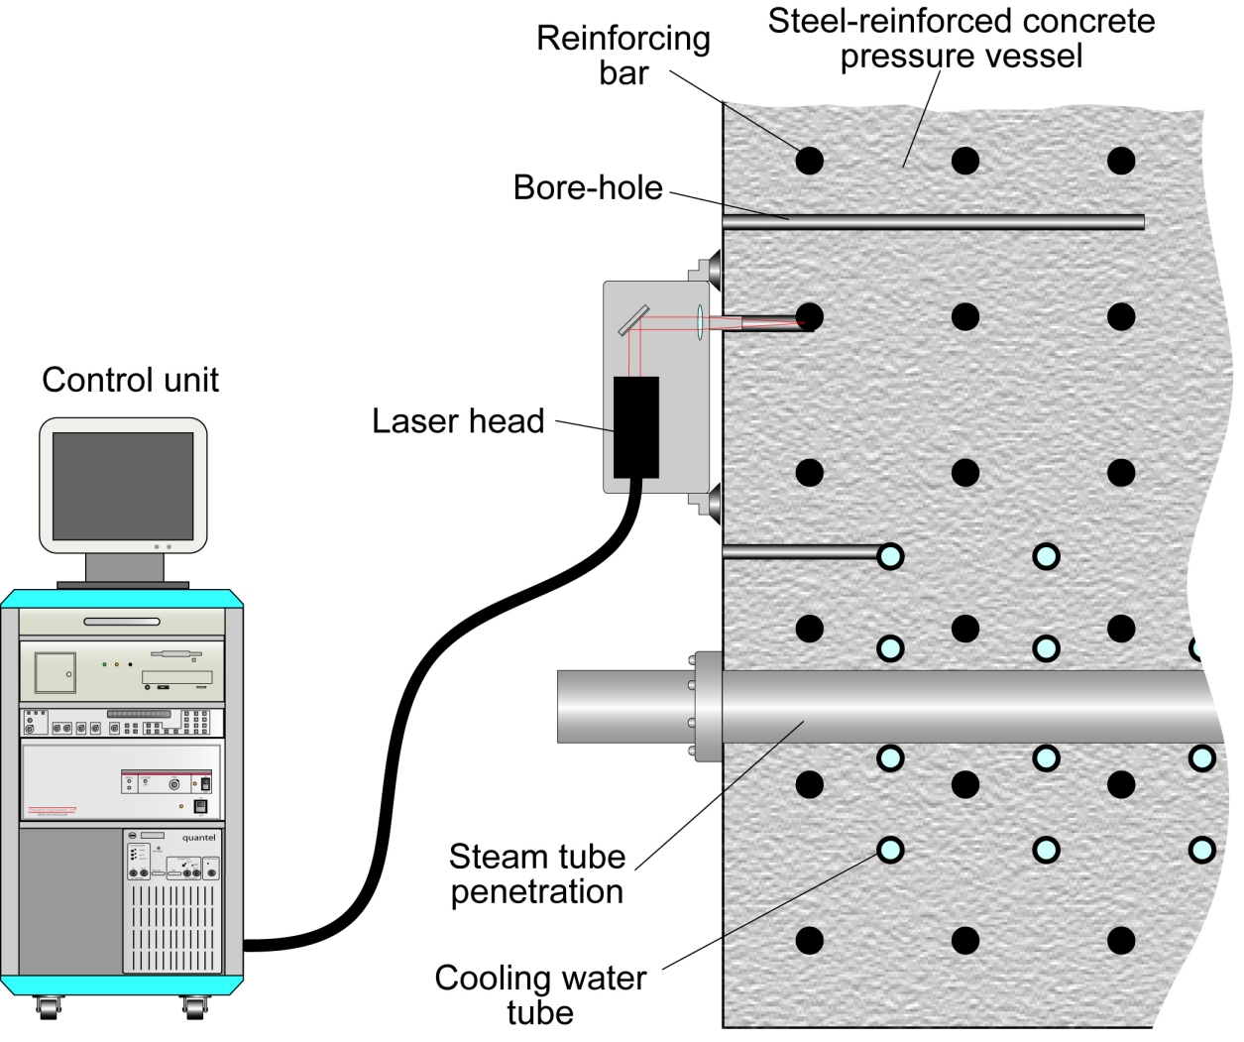
Schematic diagram illustrating the method of deployment of the LIBS instrument

The laser module, which weighs approximately 25 kg, was attached to the pressure vessel wall by means of either i) mechanical attachment to bolt anchor points within the wall or ii) heavy-duty vacuum cups designed for use with rough surfaces. The latter method of attachment incorporated a multiply redundant design and other safety features to minimize the risk of the instrument becoming detached from the wall through, for example, failure of the vacuum pumps. The instrument incorporated a remote viewing camera and an array of high-intensity LEDs used to illuminate the inside of the bore-hole. A view of the inside of the bore-hole was displayed on a monitor and the operator could adjust the optical alignment of the instrument using remote-controlled steering and focussing of the laser beam.
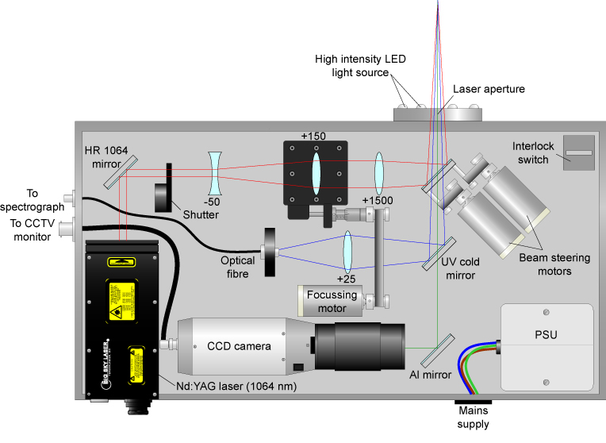
Schematic diagram of the laser module of the telescope LIBS instrument used to identify reinforcing bars and cooling water tubes within the concrete pressure vessel of a Magnox reactor

Identification of the metallic component was achieved by activating the high-power laser for a period of several seconds. Results of the measurement were displayed on the computer monitor and stored to the hard-drive together with the bore-hole identification number. Identification of a reinforcing bar / cooling water tube could be performed within 15 minutes, including the time needed to attach the laser module to the reactor pressure wall and align the laser beam with the metallic component. A view of the laser module attached to the pressure vessel wall is given below.

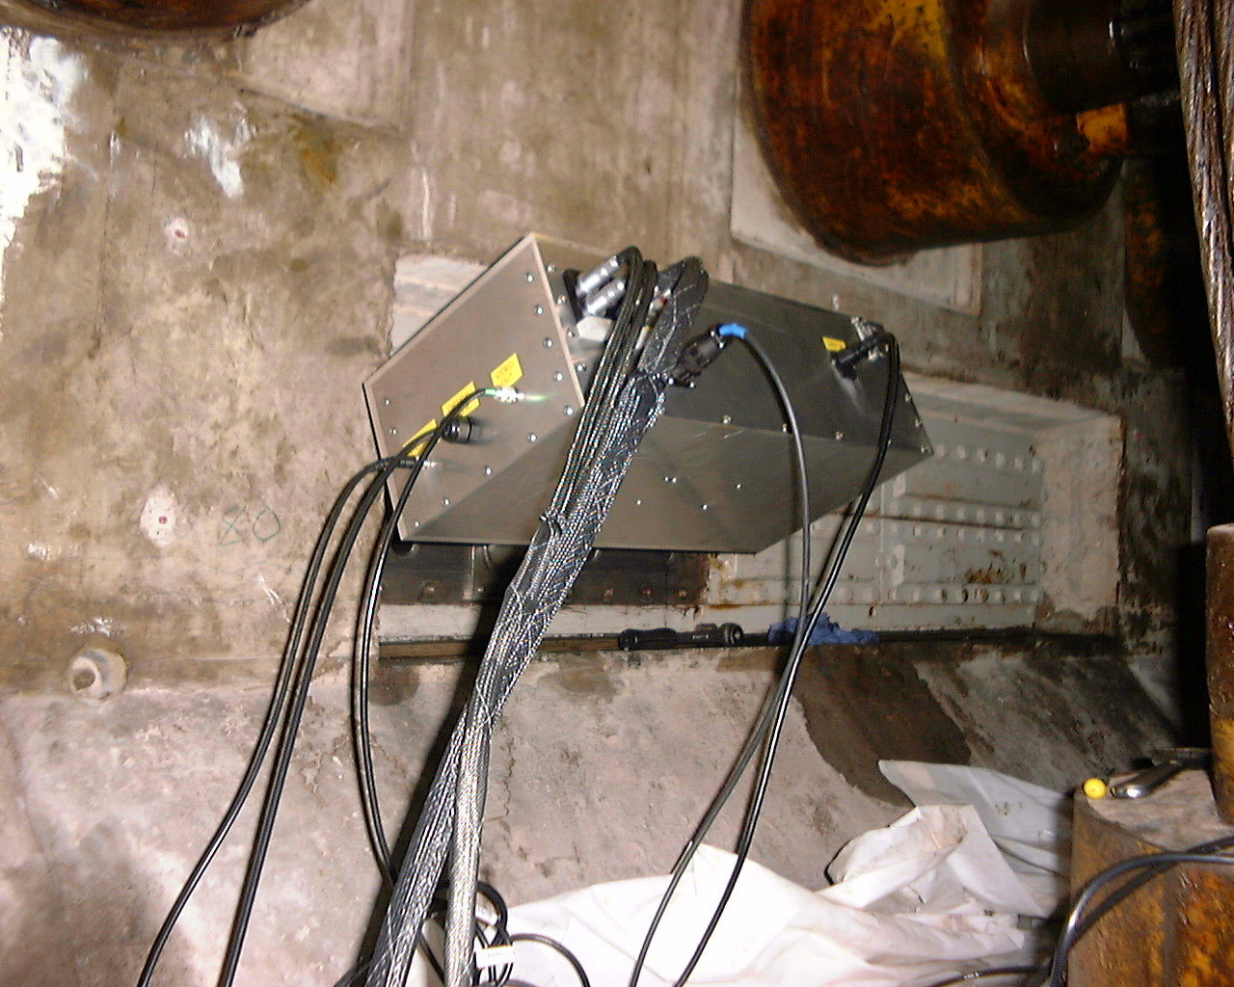
Images of the LIBS instrument being deployed at the reinforced concrete pressure vessel wall of a Magnox reactor

