
Remote characterization of high-level radioactive waste at the THORP nuclear reprocessing plant

Background
In the THORP (Thermal Oxide Reprocessing Plant) facility at Sellafield, West Cumbria, spent fuel from nuclear reactors around the world is sheared into short pieces between 2.5cm and 10cm in length as a precursor to fuel dissolution. The sheared fuel pieces, comprising metal cladding and fuel, fall down a chute into a perforated basket which is suspended in hot (90ºC) 7M nitric acid. For operational reasons, the plant uses a total of seven baskets. As a consequence of increased levels of corrosion of the baskets it became necessary to replace them to allow continued operation of the dissolution cycle.
Routine camera inspections had identified an accumulation of a solid material in the upper, vapour area of the basket. Characterization of this material was required to aid waste sentencing of the redundant baskets. Radiometric measurements were taken to identify the radionuclide inventory of the deposit but as these provided no information on the non-radioactive components, full characterization was not possible. Due to the difficulties in taking an active sample from behind the biological shield and the subsequent difficulties with laboratory analysis, a remote method for analysis was investigated.

The LIBS solution
Optical access to the material was possible via a 1-metre thick lead-glass radiation shield window. The component could be positioned approximately 3 metres beyond the window and raised / lowered by means of a hoist within the hot cell. In September 2001 Applied Photonics Ltd carried out the first remote analysis of a material within a hot cell by directing the laser beam of a telescope LIBS instrument (LIBSCAN) through a lead-glass radiation shield window.
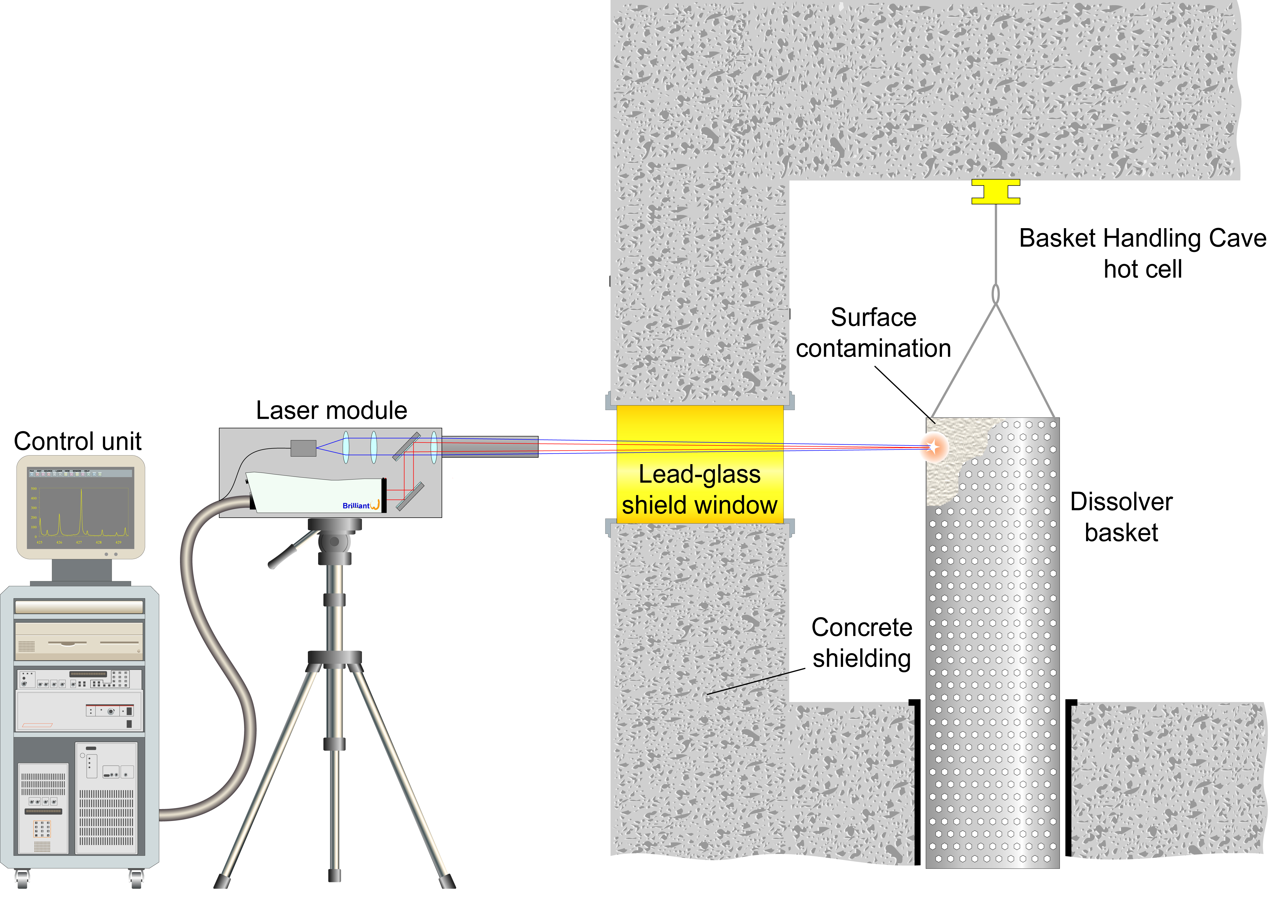

Schematic showing the deployment of the telescopic LIBS instrument at the THORP plant

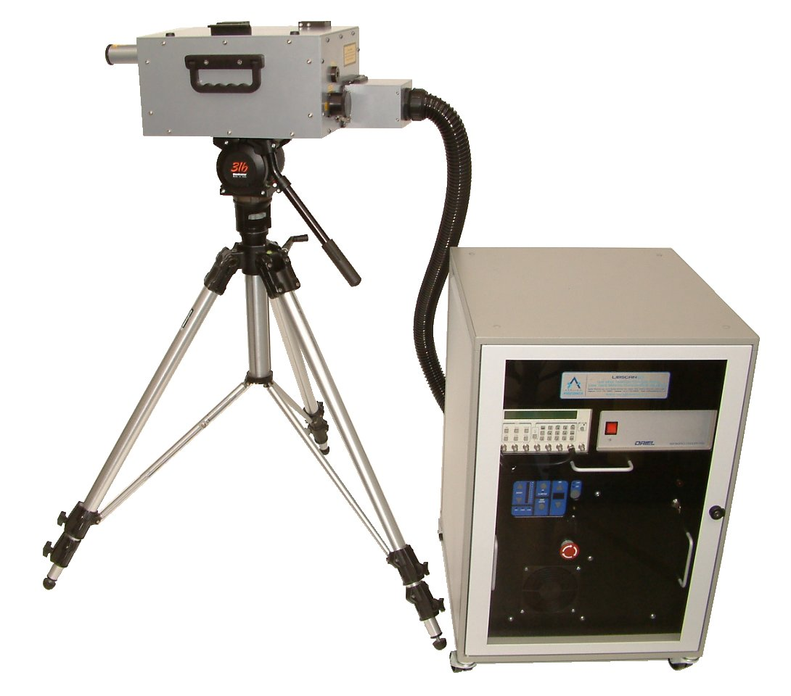
The results of the analysis showed that the contaminant material was rich in zirconium and molybdenum. Combining this information with existing knowledge of the chemistry of the process, it was deduced that the contaminant material consisted mainly of zirconium molybdate - a material that is known to form during the reprocessing of spent fuel and which is largely insoluble in nitric acid. The results of the LIBS measurements combined with the radionuclide analysis confirmed that an existing on-site storage facility could be used to receive the redundant dissolver baskets.

LIBSCAN 50 instrument

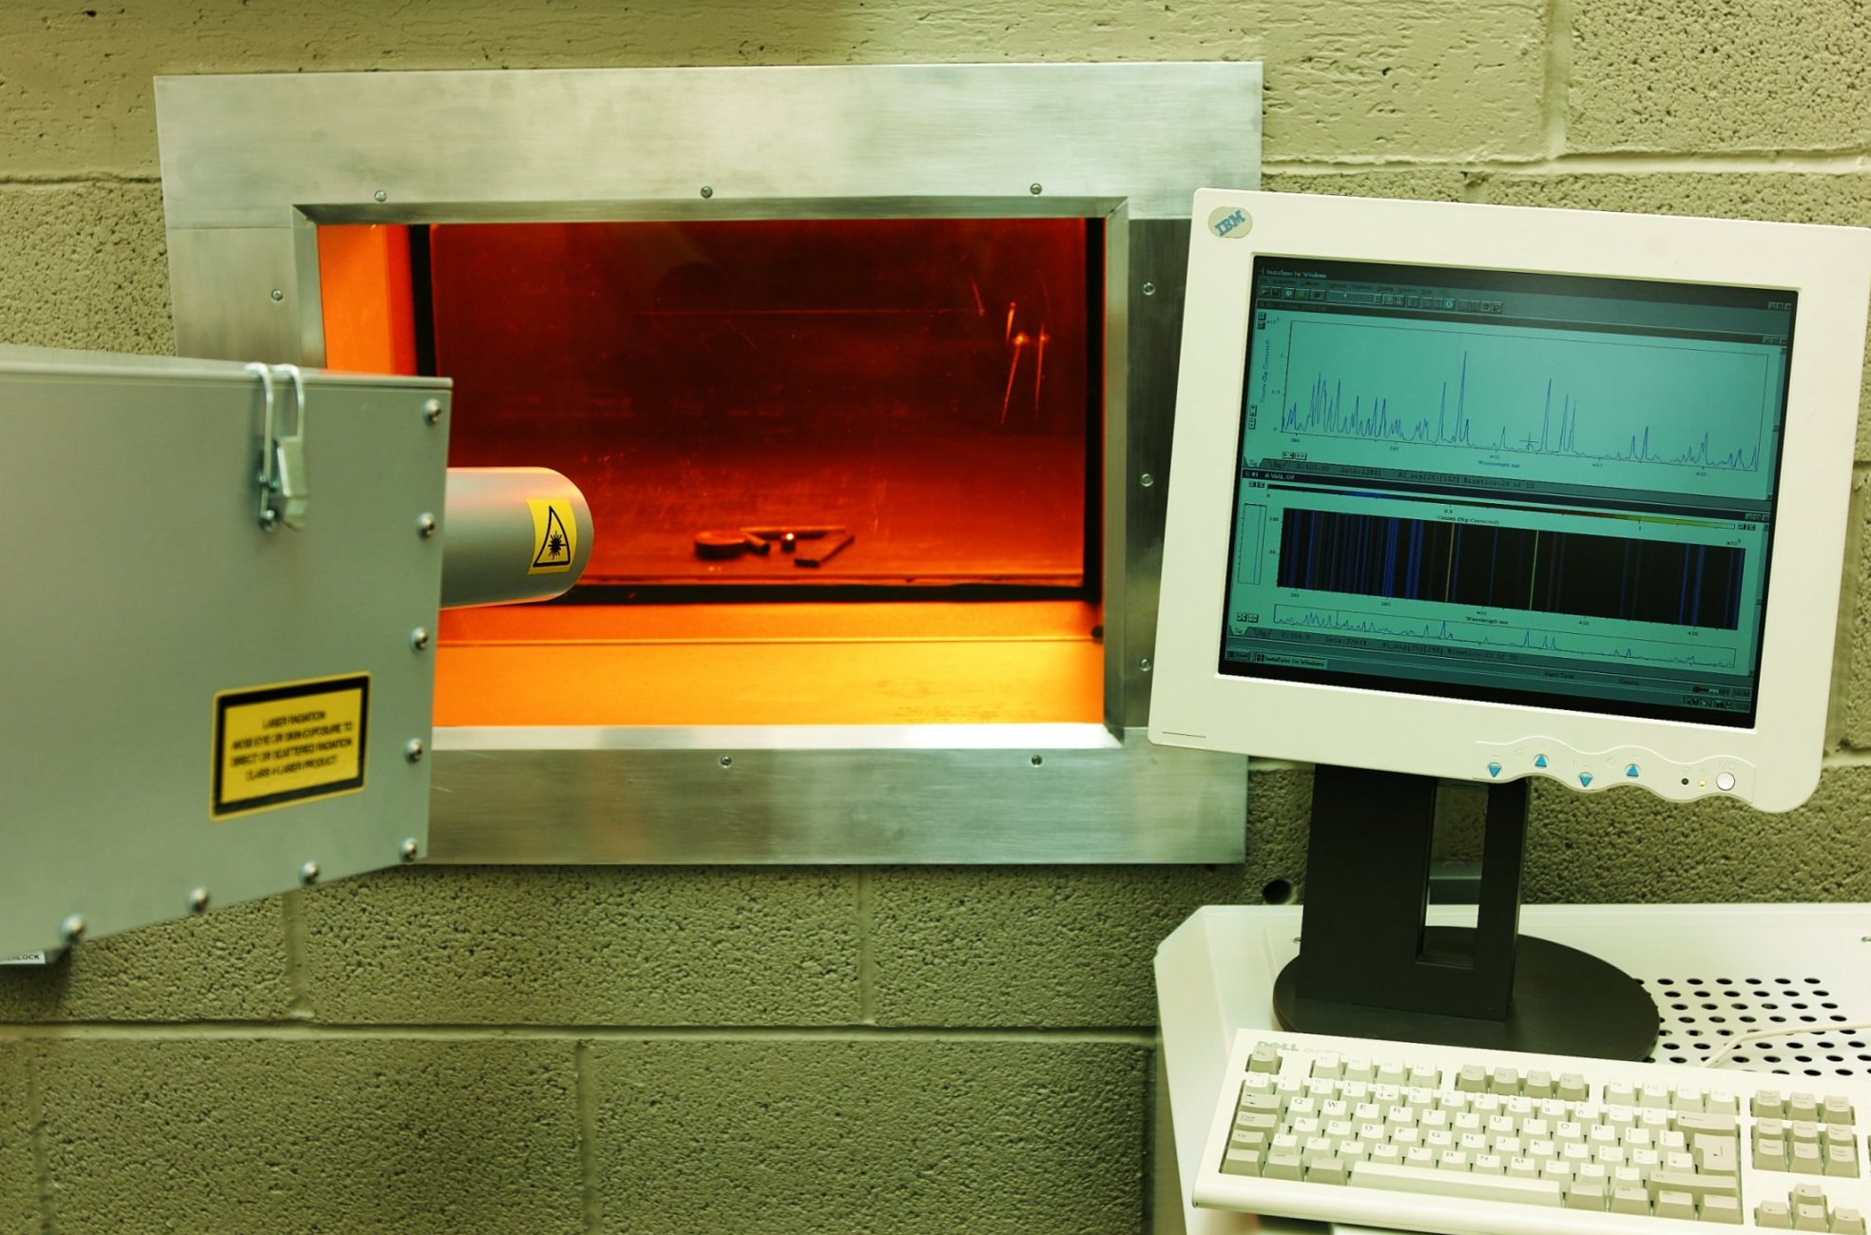
Laser beam of the LIBSCAN instrument being directed through the lead glass shield window

References
A I Whitehouse, J Young, C P Evans, Extreme LIBS, Presented at: LIBS 2002, September 25 - 28 2002, Orlando, Florida, USA
A I Whitehouse, J Young, C P Evans, A Brown (Applied Photonics Ltd.), J Franco, A Simpson (BNFL Instruments Inc.), Remote compositional analysis of spent-fuel residues using Laser-Induced Breakdown Spectroscopy, Presented at: Waste Management 2003 Symposium (WM '03) February 23 - 27 2003, Tucson, Arizona, USA
A I Whitehouse, J Young, C P Evans, A Brown (Applied Photonics Ltd.), J Franco, A Simpson (BNFL Instruments Inc.), Remote Characterization of HLW using Laser-Induced Breakdown Spectroscopy, Presented at: 10th International High-Level Radioactive Waste Management Conference (IHLRWM), March 30 - April 2, 2003, Las Vegas, Nevada, USA

