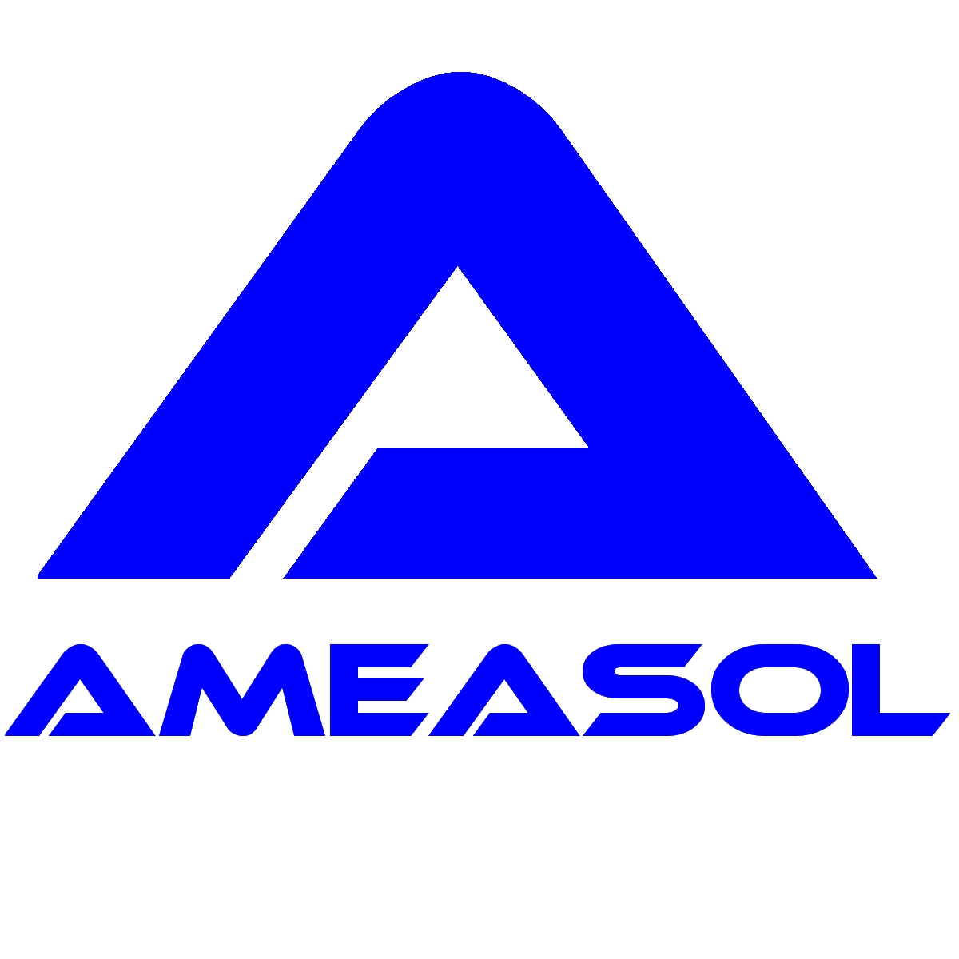
In-situ compositional analysis of Advanced Gas-cooled Reactor (AGR) steam generator tubes

Background
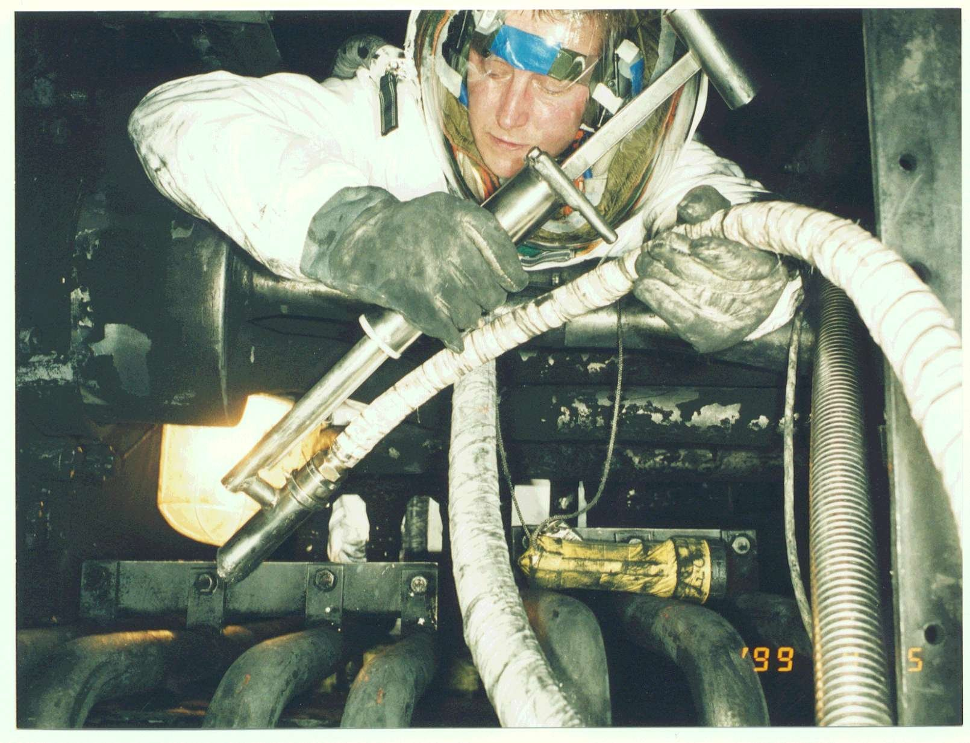
A lifetime review for the UK’s Hunterston ‘B’ and Hinkley Point ‘B’ Advanced Gas-Cooled Reactor (AGR) nuclear power stations identified superheater steam tube bifurcation cracking as a commercial threat to the estimated 35-year operation of the boiler plant. Inspection of up to 528 bifurcations in each of four reactors was required in order to identify the components that were at risk of failure prior to the end of station life. The material properties of the bifurcation casts are primary factors in determining the risk of an individual component failing. A survey of the boiler manufacturing case history identified a number of casts having low creep ductility properties leading to an increased risk of the component failing within the remaining operating life of the stations. The location of these low creep ductility casts within the total population of 2112 bifurcations was, unfortunately, not known. It was known that the low creep ductility casts exhibited abnormally high copper content in comparison to other 316H stainless-steel casts. In-vessel measurements of the copper content of the bifurcations could, therefore, be used to quickly identify the components manufactured from this cast allowing further inspection techniques and repair procedures to be targeted only where necessary.
Deployment of LIBS probe within an AGR superheater

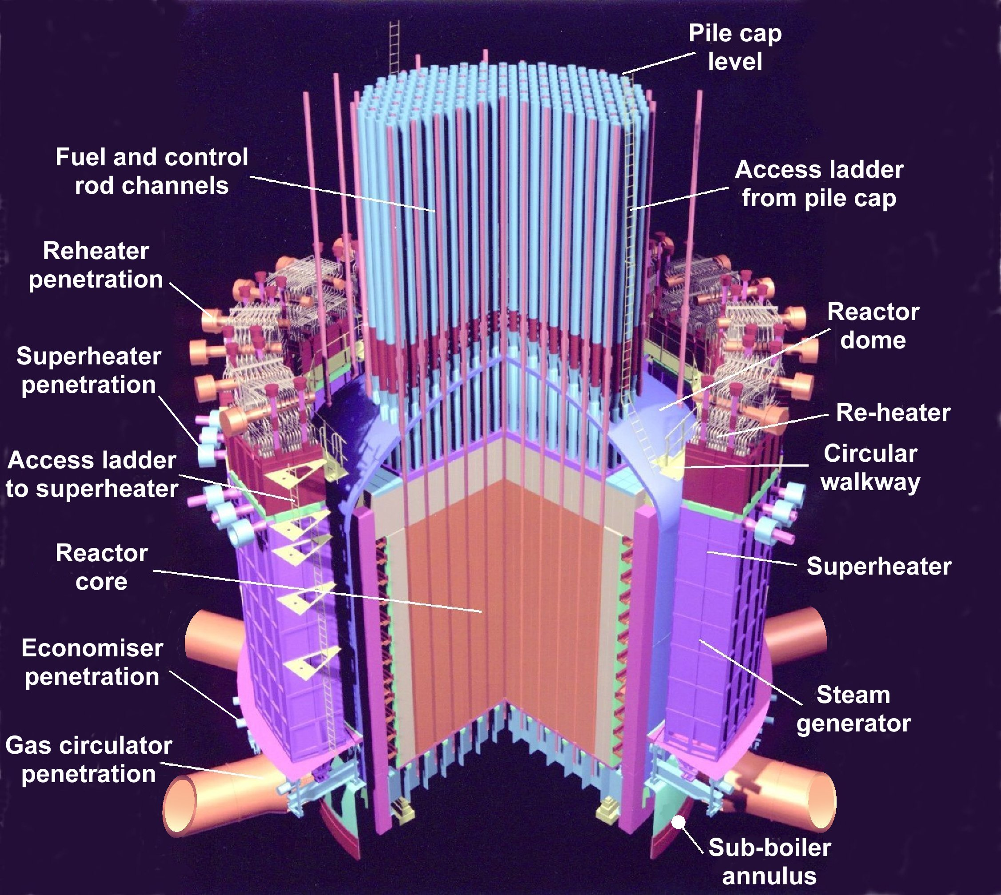
The LIBS solution
A fibre-optic LIBS instrument based on a fibre-coupled remote probe was chosen as being suitable for this application. The instrument was to be deployed during a routine reactor outage programme with the LIBS control module housed in a safe area above the pile cap and the probe/umbilical deployed within the reactor pressure vessel via a man-access route. The environment of the vessel is such that the umbilical and probe needed to be able to withstand temperatures of around 60°C, radiation dose rates of up to 2 mSv/hr and be sufficiently rugged to minimize risk of damage from mechanical shock and rough handling.
Schematic of an AGR

In order to access each of the 528 bifurcations in a reactor, a 75 metre long umbilical was required; this length being far in excess of any previously reported industrial application of a fibre-optic LIBS system. A single optical-fibre design was used as previous work at our laboratories has demonstrated that this is the most simple, practical and efficient configuration of a fibre-optic LIBS system. The analytical requirements of this application were such that the copper content of each bifurcation needed to be established as being either low (<0.06%), intermediate (0.06%<Cu≤0.2%) or high (>0.4%).

The system was used during the routine reactor outage programmes for these stations during the summer of 1999 and was able to determine the copper content over the range 0.04% to 0.60% (by mass) of each bifurcation to an accuracy of approximately ±25% and with a measurement time per bifurcation of less than 3 minutes.

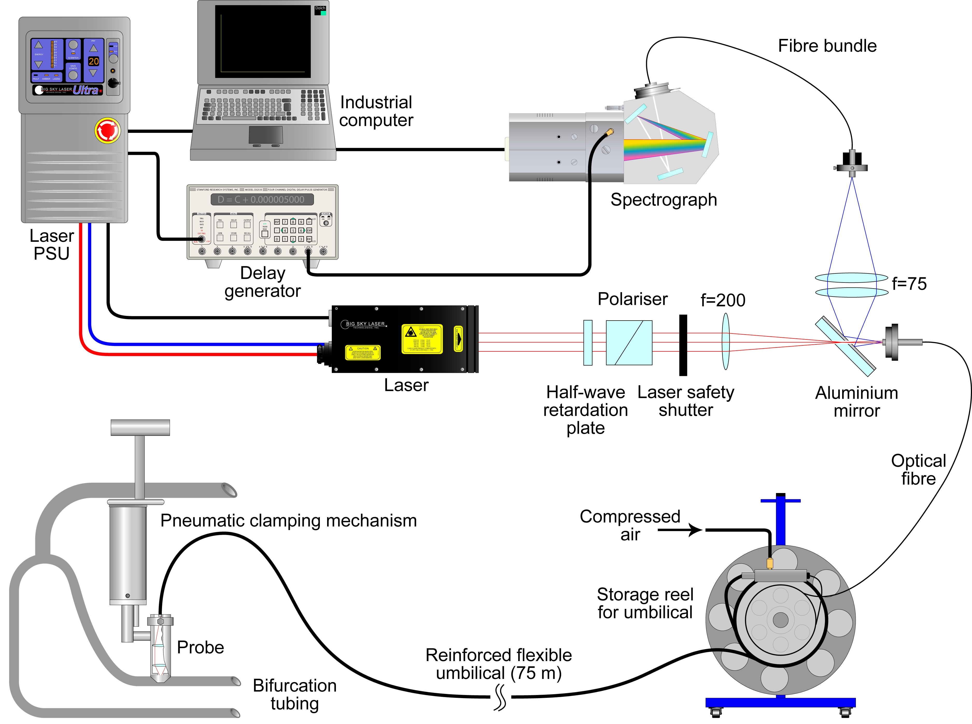

Schematic of the fibre-optic LIBS instrument deployed at the AGR nuclear power stations

References
S Lawson, J Wright, J Young, A I Whitehouse, Inspection in a tight corner, Nuclear Engineering International, (March 2000)
A I Whitehouse, J Young, I M Botheroyd, S Lawson, C P Evans, J Wright, Remote material analysis of nuclear power station steam generator tubes by laser-induced breakdown spectroscopy, Spectrochimica Acta, Part B, 56, (2001) 821-830.
A I Whitehouse, J Young, C P Evans, Extreme LIBS, Presented at: LIBS 2002, September 25 - 28 2002, Orlando, Florida, USA

